Inclement Weather
LRTA Virtual Learning Plan
Schedule:

Time: | Mod: | Length of Mod:
10:15-11:00: Direct Instruction  11:00-11:20: Small Group | Mod 1 | 65 min
11:25-12:10: Direct Instruction  12:10-12:30-Small Group | Mod 2 | 65 min
12:30-1:00 Lunch on your own | Lunch | 30 min
1:00-1:45: Direct Instruction  1:45-2:05: Small Group | Mod 3 | 65 min
2:10-2:55: Direct Instruction  2:55-3:15: Small Group | Mod 4 | 65 min

- Students will go to google.com to make sure they are signed-in
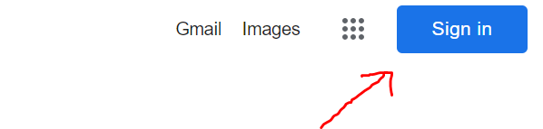
- Students will use their BCPS Username and Password.
- Once they are signed in, click the dots in the right hand corner
- Click the Google Meets Icon
- Enter the Google Meet Code for the Corresponding Teacher. Each code is the email Username: XXXX
Example: XXXX

